
Journal of Sustainable Smart Systems in Education & Environment (JSSSEE), e-ISSN: XXXX-XXXX
Title of the Article (Bold, Title Case, Centered)
Author 1, Affiliation 1, Email, ORCID: [0000-000X-XXXX-XXXX]
Author 2, Affiliation 2, Email….
Corresponding Author: Name, Email

Abstract
Insert a concise summary (200–250 words) describing the background, purpose, methods, key findings, and conclusions of the study. Avoid citations and abbreviations.
Keywords (4-6): Smart Education, Sustainability, IoT, Environmental Technology, AI in Learning

1. Introduction
Provide background, motivation, and significance. Identify gaps in prior research and state objectives. End with a summary of the paper’s organization.

2. Literature Review
Critically review relevant research. Discuss frameworks, theories, or related work that informs your study. Highlight gaps your research fills.

3. The Approach
Describe your approach or methodology clearly. Provide sufficient details to allow replication. Include tables, figures, and equations that illustrate your workflow, system, or model setup.
Example: Numbered List
- Data from sensors was aggregated into a single dataset.
- Mean values were computed for each variable.
- The system automatically triggered adjustments based on thresholds.

Example: Bullet List
- The proposed system reduced energy waste by 12%.
- Data accuracy improved through adaptive sampling.
- The model demonstrated strong scalability in testing.
Example: Algorithm
Input: SensorData[], Threshold, TimeInterval
Output: AdjustedEnergyUsage
1. Initialize totalEnergy ← 0
2. For each record r in SensorData:
If r.energy > Threshold then
r.energy ← Threshold
End If
totalEnergy ← totalEnergy + r.energy
3. Calculate averageEnergy ← totalEnergy / length(SensorData)
4. If averageEnergy > TargetValue then
ReduceEnergyUsage()
Else
MaintainCurrentUsage()
5. Return AdjustedEnergyUsage
Algorithm 1: Smart Energy Optimization Algorithm

Example: Table
Table 1: Summary of Experimental Parameters
Parameter | Description | Value | Unit
Sensor Type | Temperature sensor (DHT22) | 24.5 | °C
Data Interval | Sampling period | 60 | seconds
Nodes | Number of devices in IoT network | 15 | —

Example: Figure
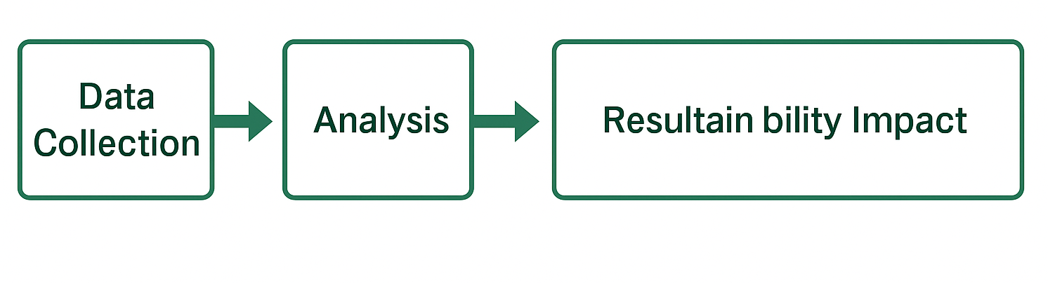
Figure 1: Framework of the Proposed Smart Monitoring Architecture.
Example: Equation:
E_eff = (P_out / P_in) × 100 (1)
Where E_eff = efficiency (%), P_out = output power, and P_in = input power.

Citation and Cross-Reference Examples
A. APA In-text Citations (biblatex)
• Journal article (narrative): Smith and Lee (2024) report significant savings.
• Journal article (parenthetical): Recent work confirms this (Smith & Lee, 2024).
• Book (narrative): Brown (2022) argues for curriculum change.
• Book (parenthetical with pages): See (Brown, 2022, pp. 45–47).
• Chapter in an edited book: Learning analytics have matured (Miller, 2023).
• Conference paper: Edge AI improves responsiveness (Ali & Zhao, 2021).
• Thesis: For a full system design, see Lopez (2020).
• Report (organization as author): World Health Organization (2020) provide guidance.
• Web/online (with access date in .bib): SDGs overview (United Nations, 2023).
• Dataset: We rely on (Green Campus Initiative, 2024) for training/validation.
• Software/tool: Metrics computed via (Rahman & Gupta, 2023).
• Standard/specification: Compliance follows (ISO 50001: Energy Management Systems,
2018).
• No date: Prototype details (Taylor, n.d.).
B. Citation Variants
• Multiple sources (one set of parentheses): (Brown, 2022; Smith & Lee, 2024; United
Nations, 2023).
• With locator (pages/chapters/sections): (Smith&Lee, 2024, p. 21), (United Nations, 2023,
pp. 10–12), (Brown, 2022, Chapter 3).
• Signal phrase/prefix: (see also Miller, 2023); (cf. Ali & Zhao, 2021, p. 5).
• Author-only / year-only: Smith and Lee emphasize . . . ; published in 2024.
• Author + year in parentheses: Smith2024.
• Direct quote with page: Brown (2022, p. 45) writes, “. . . quoted text . . . ”.
• Secondary citation (discouraged, but if unavoidable): (as cited in Smith & Lee, 2024).
• \autocite behaves like parenthetical (since we mapped it): (United Nations, 2023).
C. Citing Tables, Figures, and Equations (cleveref)
Use automatic names and numbering with \cref (or \Cref at sentence start).
• Single object in sentence: Device settings are listed in Table 1.
• Sentence start (capitalized): Figure 1 shows the overall architecture.
• Equation: Efficiency is computed by Equation (1).
• Multiple objects: See Figure 1 and Table 1.
• Range: Compare Tables 1 to 1 (tables) or Equations (1) to (1) (equations).

4. Results
Present findings clearly using text, tables, and figures. Do not interpret results here. Ensure each table and figure is referenced in the text.

5. Discussion
Interpret findings, compare them with prior studies, and explain implications. Discuss limitations and potential applications.

6. Conclusion and Future Work
Summarize main findings and propose future research directions.

7. Acknowledgements
Recognize individuals or institutions that contributed to the study but are not listed as authors.

8. Funding
Mention financial support or state: 'This research received no external funding.'

9. Conflict of Interest
Declare conflicts or state: 'The authors declare no conflict of interest.'

10. References
List all references in APA 7th Edition format. Ensure each citation has a corresponding reference entry.
Smith, J. A., & Lee, R. T. (2024). Smart IoT Systems for Green Campuses. *Journal of Sustainable Technologies, 12*(3), 45–59. https://doi.org/10.xxxx/xxxx
Brown, L. (2022). *Smart Education for Sustainability*. Routledge.
United Nations. (2023). *Sustainable Development Goals Report 2023*. https://unstats.un.org/sdgs

